Develop Framework for API

1. Create one folder in your C driver i.e. SAMA-MPP
2. Inside this folder create three folders

* mppworkspace
* mpprepository
* mppgitcode

1. Open latest eclipse (having Maven by default installed)

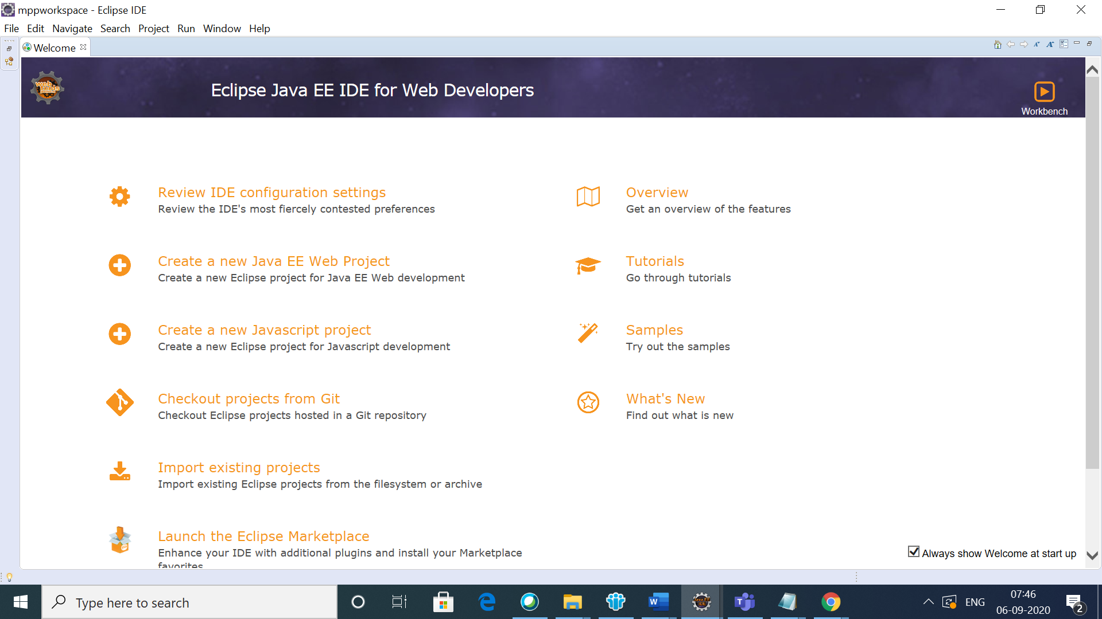

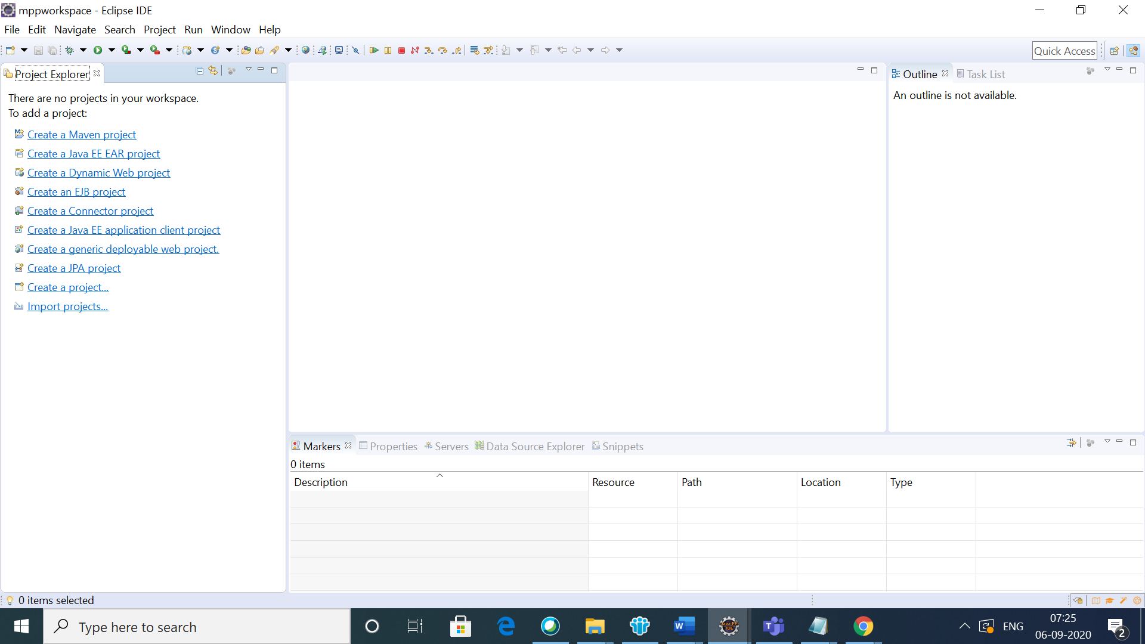

1. Create one Maven Project

Click on Maven🡪 New🡪Other

Under wizards, type Maven

Select Maven Project and click on Next button

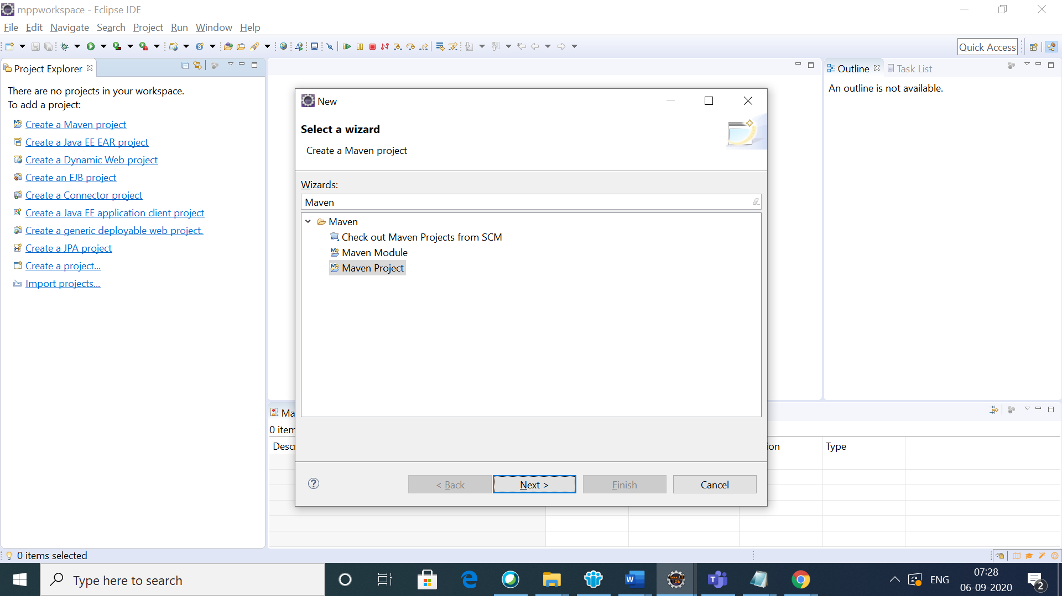

Select “Create a simple project check box (skip architect selection)” and then click on Next button.

1. Enter group ID ,Artifact ID , Version and Packaging as per project.

Artifact ID : com.sama.mpp

Group ID : sama-mpp-api-tests-automation

Version : 0.0.1-SNAPSHOT

Packaging POM : pom

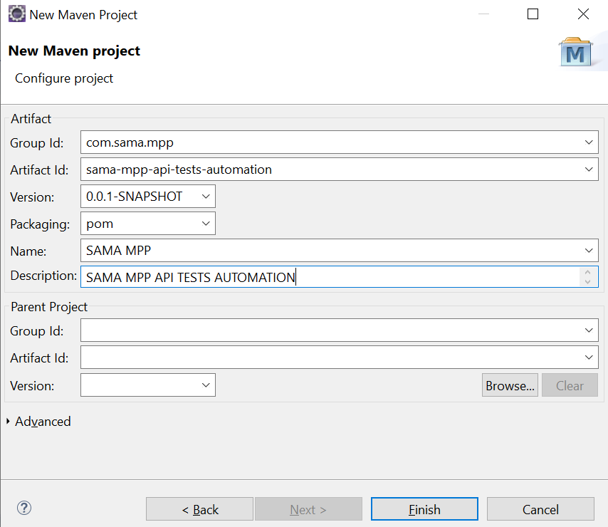

1. Create Maven Modules as per project requirements

Select Maven module and click on next button.

Then click on Finish button.

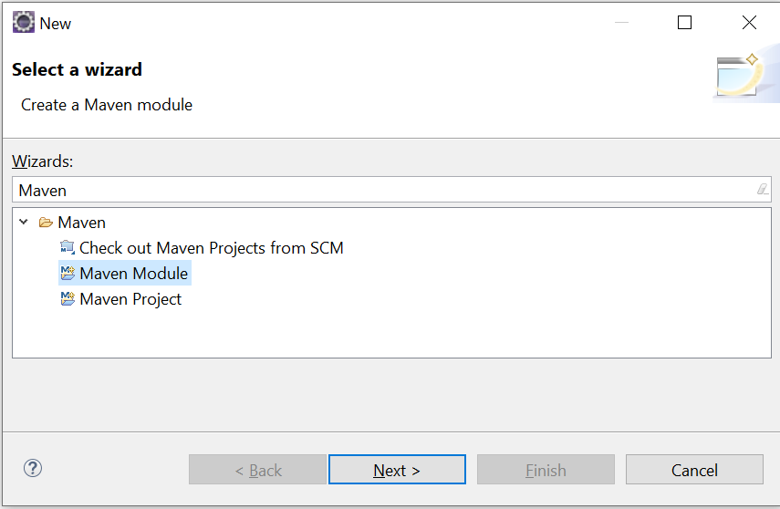

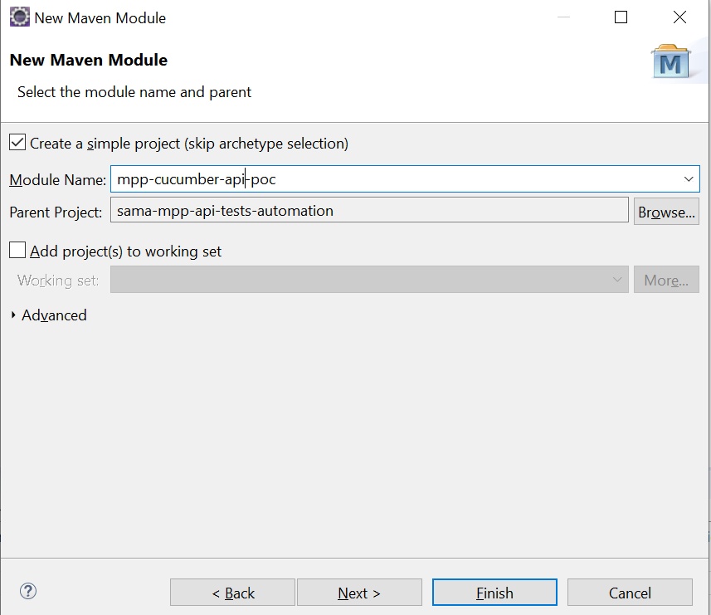

1. If there is no intenet available in your test environment, then you must make few changes in your Parent POM File.

Firstly, download *maven-4.0.0.xsd and settings-1.0.0.xsd files from internet and put it in the Parent folder.*

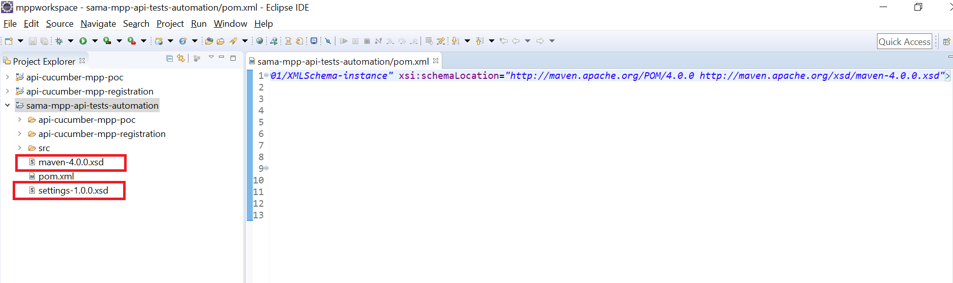

*Secondly, change the xsi:schemaLocation in your parent POM*

xsi:schemaLocation=*"maven-4.0.0.xsd”*

Click on save button in eclipse.

Note : In each module, create one folder called input and put the *maven-4.0.0.xsd and settings-1.0.0.xsd files. See below scrrenshot.*

*In addition, change the xsi:schemaLocation in your each module pom*

xsi:schemaLocation=*" ./src/test/resources/com/sama/ach/cucumber/input/maven-4.0.0.xsd”*

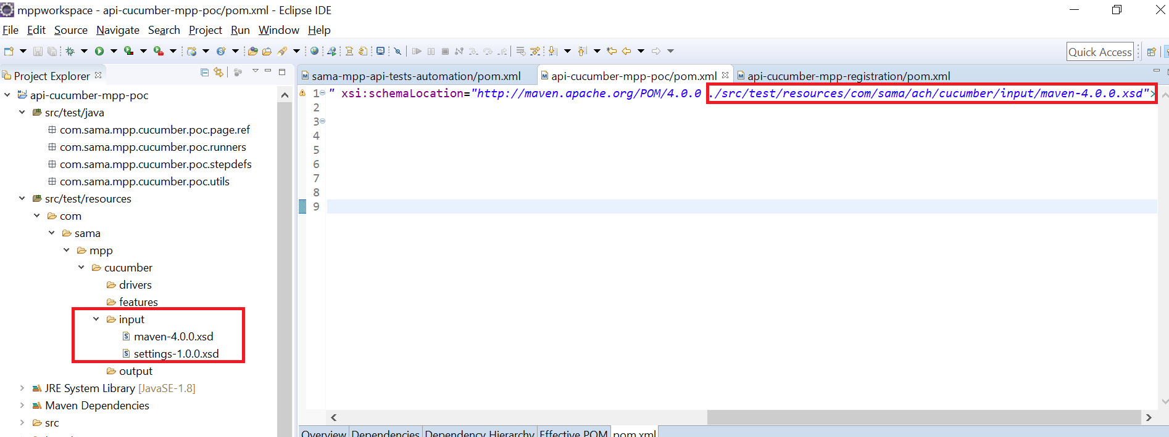

1. Change the Java version is Parent POM by addition below code under build tag and click on save button.

<build>

<pluginManagement>

<plugins>

<plugin>

<groupId>org.apache.maven.plugins</groupId>

<artifactId>maven-compiler-plugin</artifactId>

<version>3.6.0</version>

<configuration>

<source>1.8</source>

<target>1.8</target>

<encoding>UTF-8</encoding>

<forceJavacCompilerUse>true</forceJavacCompilerUse>

</configuration>

</plugin>

</plugins>

</pluginManagement>

</build>

**Note:** Do update project if you are getting any error ( Select parent project🡪Right Click 🡪Maven🡪 Update Project )

1. Update the Java Path under windows🡪preference->java🡪installed JREs with below

C:\Program Files\Java\jdk1.8.0_211\jre

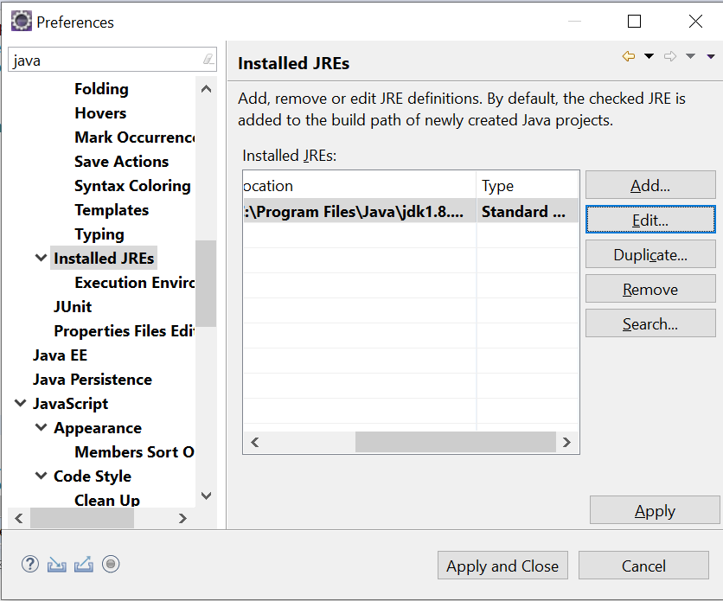

1. Change the settings.xml path under Maven🡪 User Settings

C:\SAMA-MPP\mpprepository\settings.xml

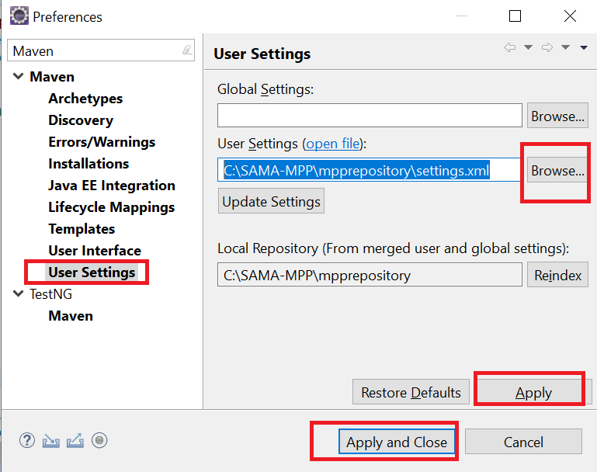

1. Make below changes in settings.xml file.

Open the settings.xml file in notepad++ and make below two required changes.

First, change the local repository path.

Secondly, change the xsi:schemaLocation path as marked in below scrrenshot.

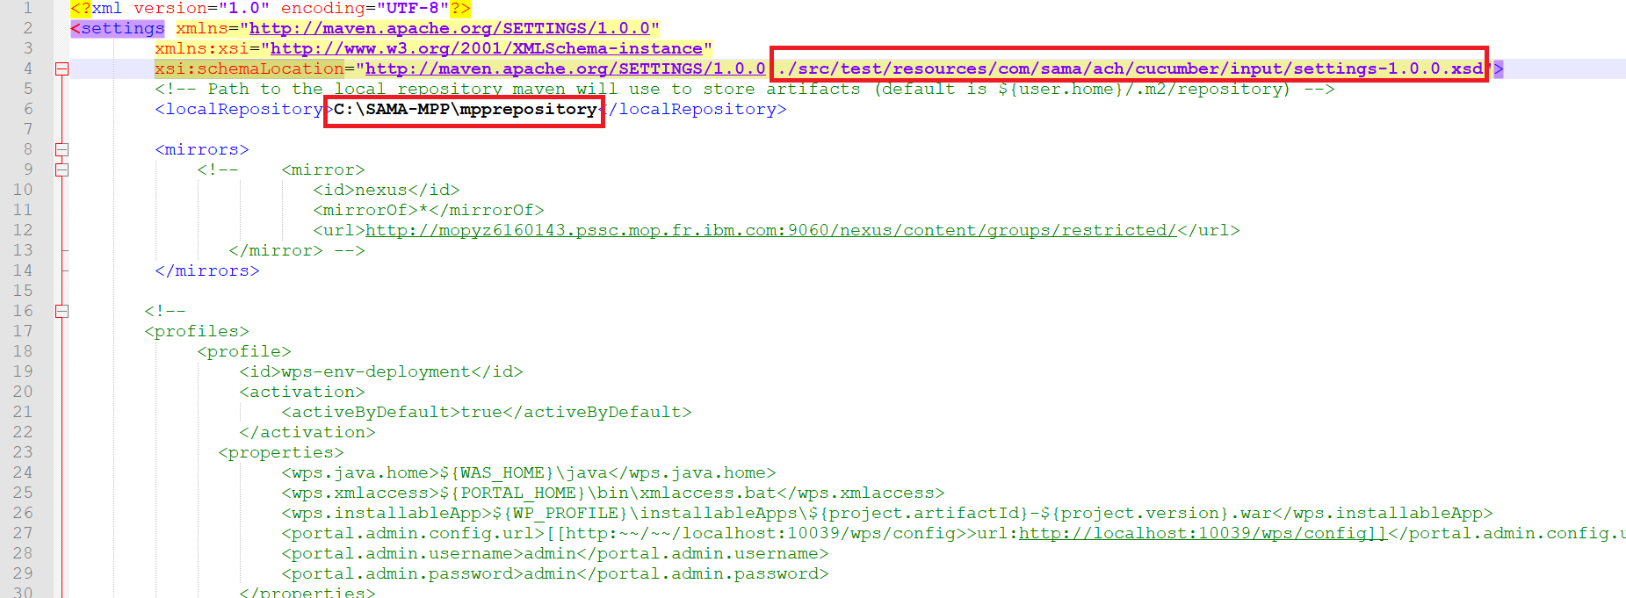

1. Add the required dependencies and properties in the **Parent** POM

<properties>

<local.jars.repository>C:\SAMA-MPP\mpprepository</local.jars.repository>

<apache.maven.binDirectory>C:\Users\DeepakKumar\Documents\Hydro Ottawa limited (HOL)\Project Software Installers\apache-maven-3.6.1-bin\apache-maven-3.6.1\bin</apache.maven.binDirectory>

</properties>

<dependencies>

<!-- https://mvnrepository.com/artifact/org.seleniumhq.selenium/selenium-java -->

<dependency>

<groupId>org.seleniumhq.selenium</groupId>

<artifactId>selenium-java</artifactId>

<version>3.141.59</version>

<scope>system</scope>

<systemPath>${local.jars.repository}\selenium-server-standalone-3.141.59.jar</systemPath>

</dependency>

<!-- https://mvnrepository.com/artifact/io.cucumber/cucumber-java -->

<dependency>

<groupId>io.cucumber</groupId>

<artifactId>cucumber-java</artifactId>

<version>4.2.0</version>

<scope>system</scope>

<systemPath>${local.jars.repository}\cucumber-java-4.2.0.jar</systemPath>

</dependency>

<dependency>

<groupId>io.cucumber</groupId>

<artifactId>cucumber-core</artifactId>

<version>4.2.0</version>

<scope>system</scope>

<systemPath>${local.jars.repository}\cucumber-core-4.2.0.jar</systemPath>

</dependency>

<dependency>

<groupId>io.cucumber</groupId>

<artifactId>cucumber-junit</artifactId>

<version>4.2.0</version>

<scope>system</scope>

<systemPath>${local.jars.repository}\cucumber-junit-4.2.0.jar</systemPath>

</dependency>

<dependency>

<groupId>junit</groupId>

<artifactId>junit</artifactId>

<version>4.12</version>

<scope>system</scope>

<systemPath>${local.jars.repository}\junit-4.12.jar</systemPath>

</dependency>

<!-- https://mvnrepository.com/artifact/commons-codec/commons-codec -->

<dependency>

<groupId>commons-codec</groupId>

<artifactId>commons-codec</artifactId>

<version>1.10</version>

<scope>system</scope>

<systemPath>${local.jars.repository}\commons-codec-1.10.jar</systemPath>

</dependency>

<!-- https://mvnrepository.com/artifact/io.cucumber/gherkin -->

<dependency>

<groupId>io.cucumber</groupId>

<artifactId>gherkin</artifactId>

<version>5.1.0</version>

<scope>system</scope>

<systemPath>${local.jars.repository}\gherkin-5.1.0.jar</systemPath>

</dependency>

<!-- https://mvnrepository.com/artifact/io.cucumber/tag-expressions -->

<dependency>

<groupId>io.cucumber</groupId>

<artifactId>tag-expressions</artifactId>

<version>1.1.1</version>

<scope>system</scope>

<systemPath>${local.jars.repository}\tag-expressions-1.1.1.jar</systemPath>

</dependency>

<!-- https://mvnrepository.com/artifact/io.cucumber/datatable -->

<dependency>

<groupId>io.cucumber</groupId>

<artifactId>datatable</artifactId>

<version>1.1.7</version>

<scope>system</scope>

<systemPath>${local.jars.repository}\datatable-1.1.7.jar</systemPath>

</dependency>

<!-- https://mvnrepository.com/artifact/io.cucumber/datatable-dependencies -->

<dependency>

<groupId>io.cucumber</groupId>

<artifactId>datatable-dependencies</artifactId>

<version>1.1.7</version>

<scope>system</scope>

<systemPath>${local.jars.repository}\datatable-dependencies-1.1.7.jar</systemPath>

</dependency>

<!-- https://mvnrepository.com/artifact/io.cucumber/cucumber-expressions -->

<dependency>

<groupId>io.cucumber</groupId>

<artifactId>cucumber-expressions</artifactId>

<version>6.2.0</version>

<scope>system</scope>

<systemPath>${local.jars.repository}\cucumber-expressions-6.2.0.jar</systemPath>

</dependency>

<!-- https://mvnrepository.com/artifact/org.hamcrest/hamcrest-core -->

<dependency>

<groupId>org.hamcrest</groupId>

<artifactId>hamcrest-core</artifactId>

<version>1.3</version>

<scope>system</scope>

<systemPath>${local.jars.repository}\hamcrest-core-1.3.jar</systemPath>

</dependency>

<!-- https://mvnrepository.com/artifact/io.cucumber/cucumber-html -->

<dependency>

<groupId>io.cucumber</groupId>

<artifactId>cucumber-html</artifactId>

<version>0.2.7</version>

<scope>system</scope>

<systemPath>${local.jars.repository}\cucumber-html-0.2.7.jar</systemPath>

</dependency>

<!-- Below 13 jars are required for Reporting -->

<!-- https://mvnrepository.com/artifact/net.masterthought/cucumber-reporting -->

<dependency>

<groupId>net.masterthought</groupId>

<artifactId>cucumber-reporting</artifactId>

<version>4.6.0</version>

<scope>system</scope>

<systemPath>${local.jars.repository}\cucumber-reporting-4.6.0.jar</systemPath>

</dependency>

<!-- https://mvnrepository.com/artifact/commons-configuration/commons-configuration -->

<dependency>

<groupId>commons-configuration</groupId>

<artifactId>commons-configuration</artifactId>

<version>1.10</version>

<scope>system</scope>

<systemPath>${local.jars.repository}\commons-configuration-1.10.jar</systemPath>

</dependency>

<!-- https://mvnrepository.com/artifact/joda-time/joda-time -->

<dependency>

<groupId>joda-time</groupId>

<artifactId>joda-time</artifactId>

<version>2.9.9</version>

<scope>system</scope>

<systemPath>${local.jars.repository}\joda-time-2.9.9.jar</systemPath>

</dependency>

<!-- https://mvnrepository.com/artifact/com.googlecode.owasp-java-html-sanitizer/owasp-java-html-sanitizer -->

<dependency>

<groupId>com.googlecode.owasp-java-html-sanitizer</groupId>

<artifactId>owasp-java-html-sanitizer</artifactId>

<version>20190325.1</version>

<scope>system</scope>

<systemPath>${local.jars.repository}\owasp-java-html-sanitizer-20190325.1.jar</systemPath>

</dependency>

<!-- https://mvnrepository.com/artifact/org.apache.velocity/velocity -->

<dependency>

<groupId>org.apache.velocity</groupId>

<artifactId>velocity</artifactId>

<version>1.7</version>

<scope>system</scope>

<systemPath>${local.jars.repository}\velocity-1.7.jar</systemPath>

</dependency>

<!-- https://mvnrepository.com/artifact/org.codehaus.plexus/plexus-utils -->

<dependency>

<groupId>org.codehaus.plexus</groupId>

<artifactId>plexus-utils</artifactId>

<version>3.0.1</version>

<scope>system</scope>

<systemPath>${local.jars.repository}\plexus-utils-3.0.1.jar</systemPath>

</dependency>

<!-- https://mvnrepository.com/artifact/com.fasterxml.jackson.core/jackson-databind -->

<dependency>

<groupId>com.fasterxml.jackson.core</groupId>

<artifactId>jackson-databind</artifactId>

<version>2.9.8</version>

<scope>system</scope>

<systemPath>${local.jars.repository}\jackson-databind-2.9.8.jar</systemPath>

</dependency>

<!-- https://mvnrepository.com/artifact/com.fasterxml.jackson.core/jackson-core -->

<dependency>

<groupId>com.fasterxml.jackson.core</groupId>

<artifactId>jackson-core</artifactId>

<version>2.9.8</version>

<scope>system</scope>

<systemPath>${local.jars.repository}\jackson-core-2.9.8.jar</systemPath>

</dependency>

<!-- https://mvnrepository.com/artifact/com.fasterxml.jackson.core/jackson-annotations -->

<dependency>

<groupId>com.fasterxml.jackson.core</groupId>

<artifactId>jackson-annotations</artifactId>

<version>2.9.0</version>

<scope>system</scope>

<systemPath>${local.jars.repository}\jackson-annotations-2.9.0.jar</systemPath>

</dependency>

<!-- https://mvnrepository.com/artifact/commons-lang/commons-lang -->

<dependency>

<groupId>commons-lang</groupId>

<artifactId>commons-lang</artifactId>

<version>2.4</version>

<scope>system</scope>

<systemPath>${local.jars.repository}\commons-lang-2.4.jar</systemPath>

</dependency>

<!-- https://mvnrepository.com/artifact/commons-io/commons-io -->

<dependency>

<groupId>commons-io</groupId>

<artifactId>commons-io</artifactId>

<version>2.4</version>

<scope>system</scope>

<systemPath>${local.jars.repository}\commons-io-2.4.jar</systemPath>

</dependency>

<!-- https://mvnrepository.com/artifact/commons-collections/commons-collections -->

<dependency>

<groupId>commons-collections</groupId>

<artifactId>commons-collections</artifactId>

<version>3.2.1</version>

<scope>system</scope>

<systemPath>${local.jars.repository}\commons-collections-3.2.1.jar</systemPath>

</dependency>

<!-- https://mvnrepository.com/artifact/org.apache.commons/commons-lang3 -->

<dependency>

<groupId>org.apache.commons</groupId>

<artifactId>commons-lang3</artifactId>

<version>3.6</version>

<scope>system</scope>

<systemPath>${local.jars.repository}\commons-lang3-3.6.jar</systemPath>

</dependency>

<!-- https://mvnrepository.com/artifact/net.sf.opencsv/opencsv -->

<dependency>

<groupId>net.sf.opencsv</groupId>

<artifactId>opencsv</artifactId>

<version>2.3</version>

<scope>system</scope>

<systemPath>${local.jars.repository}\opencsv-2.3.jar</systemPath>

</dependency>

<!-- <dependency>

<groupId>com.sama.ach</groupId>

<artifactId>ach-cucumber-portal-poc</artifactId>

<version>0.0.1-SNAPSHOT</version>

<scope>system</scope>

<systemPath>${local.jars.repository}\ach-cucumber-portal-poc-0.0.1-SNAPSHOT.jar</systemPath>

</dependency> -->

<!-- https://mvnrepository.com/artifact/io.rest-assured/rest-assured -->

<!-- rest-assured dependecy -->

<!-- https://mvnrepository.com/artifact/io.rest-assured/rest-assured -->

<dependency>

<groupId>io.rest-assured</groupId>

<artifactId>rest-assured</artifactId>

<version>4.3.1</version>

<scope>system</scope>

<systemPath>${local.jars.repository}\rest-assured-4.3.1.jar</systemPath>

</dependency>

<!-- https://mvnrepository.com/artifact/io.rest-assured/json-path -->

<dependency>

<groupId>io.rest-assured</groupId>

<artifactId>json-path</artifactId>

<version>4.3.1</version>

<scope>system</scope>

<systemPath>${local.jars.repository}\json-path-4.3.1.jar</systemPath>

</dependency>

<!-- https://mvnrepository.com/artifact/org.codehaus.groovy/groovy -->

<dependency>

<groupId>org.codehaus.groovy</groupId>

<artifactId>groovy</artifactId>

<version>3.0.5</version>

<scope>system</scope>

<systemPath>${local.jars.repository}\groovy-3.0.5.jar</systemPath>

</dependency>

<!-- https://mvnrepository.com/artifact/io.rest-assured/rest-assured-common -->

<dependency>

<groupId>io.rest-assured</groupId>

<artifactId>rest-assured-common</artifactId>

<version>4.3.1</version>

<scope>system</scope>

<systemPath>${local.jars.repository}\rest-assured-common-4.3.1.jar</systemPath>

</dependency>

<!-- https://mvnrepository.com/artifact/org.apache.httpcomponents/httpclient -->

<dependency>

<groupId>org.apache.httpcomponents</groupId>

<artifactId>httpclient</artifactId>

<version>4.5.12</version>

<scope>system</scope>

<systemPath>${local.jars.repository}\httpclient-4.5.12.jar</systemPath>

</dependency>

<!-- https://mvnrepository.com/artifact/org.apache.httpcomponents/httpmime -->

<dependency>

<groupId>org.apache.httpcomponents</groupId>

<artifactId>httpmime</artifactId>

<version>4.5.12</version>

<scope>system</scope>

<systemPath>${local.jars.repository}\httpmime-4.5.12.jar</systemPath>

</dependency>

<!-- https://mvnrepository.com/artifact/io.rest-assured/xml-path -->

<dependency>

<groupId>io.rest-assured</groupId>

<artifactId>xml-path</artifactId>

<version>4.3.1</version>

<scope>system</scope>

<systemPath>${local.jars.repository}\xml-path-4.3.1.jar</systemPath>

</dependency>

<!-- https://mvnrepository.com/artifact/commons-logging/commons-logging -->

<dependency>

<groupId>commons-logging</groupId>

<artifactId>commons-logging</artifactId>

<version>1.2</version>

<scope>system</scope>

<systemPath>${local.jars.repository}\commons-logging-1.2.jar</systemPath>

</dependency>

<!-- https://mvnrepository.com/artifact/org.junit.jupiter/junit-jupiter-api -->

<dependency>

<groupId>org.junit.jupiter</groupId>

<artifactId>junit-jupiter-api</artifactId>

<version>5.6.2</version>

<scope>system</scope>

<systemPath>${local.jars.repository}\junit-jupiter-api-5.6.2.jar</systemPath>

</dependency>

<!-- https://mvnrepository.com/artifact/org.codehaus.groovy/groovy-xml -->

<dependency>

<groupId>org.codehaus.groovy</groupId>

<artifactId>groovy-xml</artifactId>

<version>3.0.5</version>

<scope>system</scope>

<systemPath>${local.jars.repository}\groovy-xml-3.0.5.jar</systemPath>

</dependency>

<!-- https://mvnrepository.com/artifact/org.ccil.cowan.tagsoup/tagsoup -->

<dependency>

<groupId>org.ccil.cowan.tagsoup</groupId>

<artifactId>tagsoup</artifactId>

<version>1.2.1</version>

<scope>system</scope>

<systemPath>${local.jars.repository}\tagsoup-1.2.1.jar</systemPath>

</dependency>

<!-- https://mvnrepository.com/artifact/org.apache.httpcomponents/httpcore -->

<dependency>

<groupId>org.apache.httpcomponents</groupId>

<artifactId>httpcore</artifactId>

<version>4.4.6</version>

<scope>system</scope>

<systemPath>${local.jars.repository}\httpcore-4.4.6.jar</systemPath>

</dependency>

<!-- https://mvnrepository.com/artifact/org.codehaus.groovy/groovy-json -->

<dependency>

<groupId>org.codehaus.groovy</groupId>

<artifactId>groovy-json</artifactId>

<version>3.0.5</version>

<scope>system</scope>

<systemPath>${local.jars.repository}\groovy-json-3.0.5.jar</systemPath>

</dependency>

</dependencies>

1. Now create below package in **src/test/java** folder

############################

* com.sama.mpp.cucumber.poc.page.ref
* com.sama.mpp.cucumber.poc.runners
* com.sama.mpp.cucumber.poc.stepdefs
* com.sama.mpp.cucumber.poc.utils

And create below folders under **src/test/resources**

* com\sama\mpp\cucumber\downloads
* com\sama\mpp\cucumber\drivers
* com\sama\mpp\cucumber\features
* com\sama\mpp\cucumber\input
* com\sama\mpp\cucumber\output

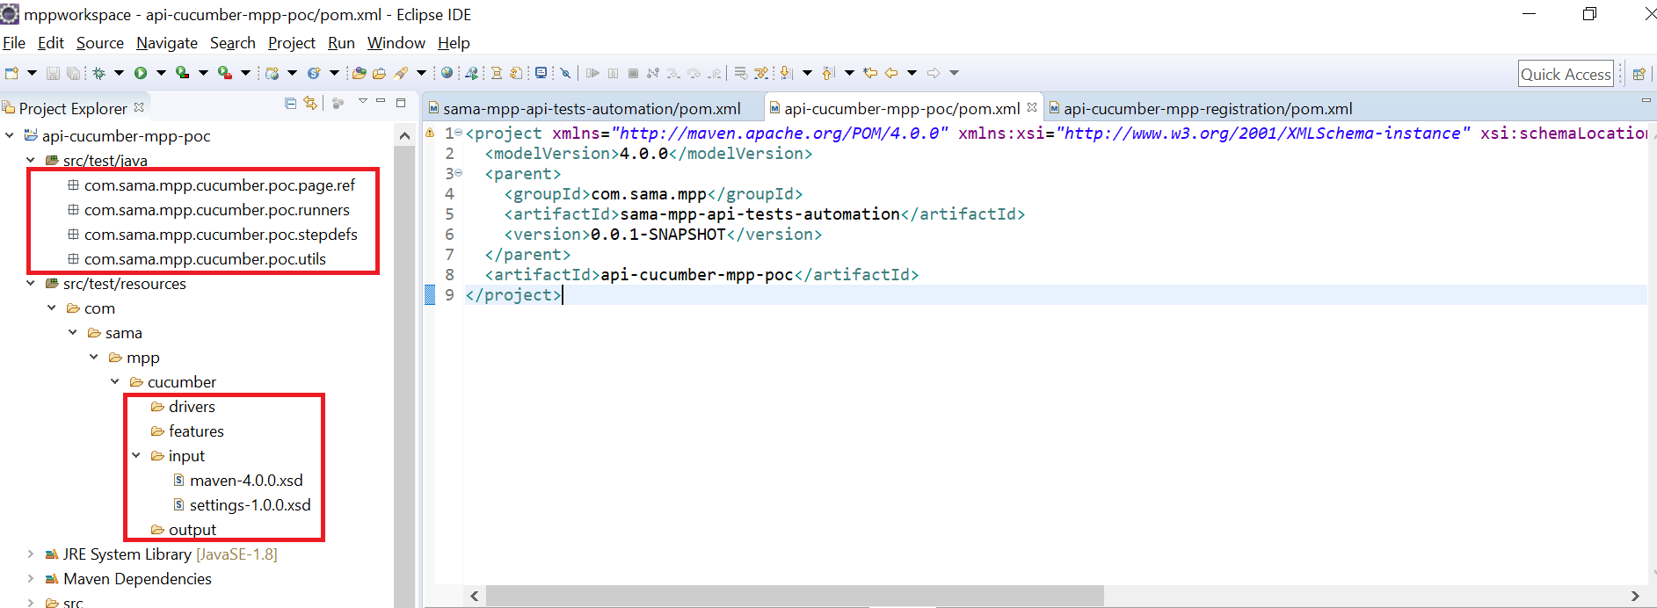

1. Create below Interface and class under src/test/java in POC Module

* POC_PageRef(Interface)
* POC_Runner(Class)
* POC_StepDefinitions( Class)
* CommonFunctions ( Class)
* SamaMPPLib ( Class)

**Note**: CommonFunctions and SamaMPPLib will implements POC_PageRef if required.

1. Now declare all variable and reference object as public static final in POC_PageRef page

**package** com.sama.mpp.cucumber.poc.page.ref;

**import** org.openqa.selenium.By;

**public** **interface** POC_PageRef {

/***************** MPP Page_Dashboard******************************/

**public** **static** **final** String ***strTextNavigate*** = "%s";

**public** **static** **final** String ***strNavigate*** = "//*[text()='%s']";

**public** **static** **final** By ***input_registrationId*** = By.*xpath*("//input[@name='registrationId']");

**public** **static** **final** By ***btn_Search*** = By.*xpath*("//*[text()='Search']");

**public** **static** **final** By ***text_RegistationError***= By.*xpath*("//*[contains(text(),'Registration ID does not exist')]");

/***************** Page_Login ******************************/

**public** **static** **final** By ***input_UserName*** = By.*xpath*("//input[@name='username']");

**public** **static** **final** By ***input_Password*** = By.*xpath*("//input[@name='password']");

**public** **static** **final** By ***btn_Login*** = By.*xpath*("//button[@id='loginButton-btnEl']//*[text()='Login']");

**public** **static** **final** By ***text_LoginErrorMPPPortal***= By.*xpath*("//p[text()='Please enter your correct User Name and/or Password.']");

}

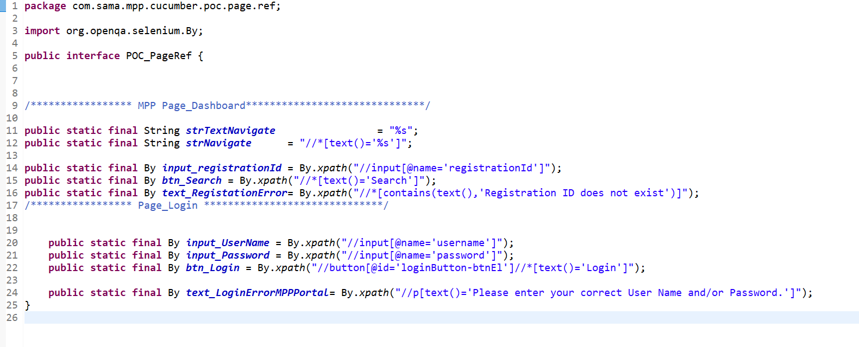

**Issues List ::**

**Issue 1 :::** if we get below errors

31mgroovy.lang.MissingMethodException: No signature of method: static io.restassured.internal.http.URIBuilder.encode() is applicable for argument types: (String, String) values: [RA_double_slash__10.158.244.98, UTF-8]

Possible solutions: hashCode()

groovy.lang.MissingMethodException: No signature of method: static io.restassured.internal.http.URIBuilder.encode() is applicable for argument types: (String, String) values: [sp, UTF-8]

Possible solutions: hashCode()

In order to resolve above issue, please install below dependency

<!-- https://mvnrepository.com/artifact/org.apache.httpcomponents/httpcore -->

<dependency>

<groupId>org.apache.httpcomponents</groupId>

<artifactId>httpcore</artifactId>

<version>4.4.6</version>

<scope>system</scope>

<systemPath>${local.jars.repository}\httpcore-4.4.6.jar</systemPath>

</dependency>

**Issue 2 :::** javax.net.ssl.SSLHandshakeException: sun.security.validator.ValidatorException: PKIX path building failed: sun.security.provider.certpath.SunCertPathBuilderException: unable to find valid certification path to requested target

Resolution :

*given*().**relaxedHTTPSValidation**(); OR

RestAssured.*RelaxedHTTPSValidation*();

RestAssured.*RelaxedHTTPSValidation*(“SSL”);

RestAssured.*RelaxedHTTPSValidation*(“TLS”);

Link : <https://www.youtube.com/watch?v=5-MMX2DbcI0>